# Lab Task 1

# 

Link: <https://www.figma.com/file/HmQyOVt3iGz491ALgSdrvW/Assignment-no-1?type=design&node-id=0%3A1&mode=design&t=962GKRFVS67SXW0U-1>

**Design**

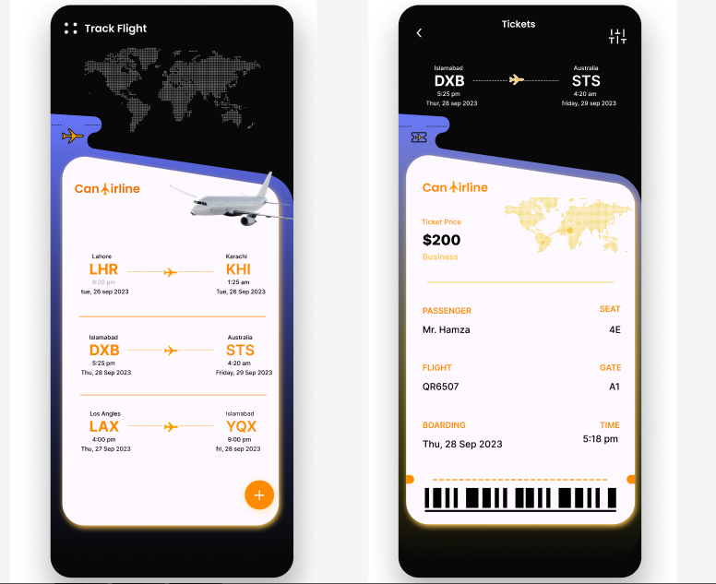

# Lab Task 3

1. Develop an information architecture for a website or app

**a. Identify the project scope and goals: Students will first understand the purpose and goals they are working on.**

**Goals of the app are:**

1. **Ease of Use**: The app is be user-friendly and intuitive, allowing users to navigate through the app easily and book tickets without any hassle.
2. **Information Accessibility**: The app provides all necessary information such as flight schedules, prices, seat availability, and more in a clear and concise manner.
3. **Personalization**: The app offers personalized recommendations based on the user’s search and booking history.

**b. Conduct a content inventory:**

1. **Home Screen**: This is the main screen that users see when they open the app. It typically includes options to search for flights, access account information, and view current promotions or deals.
2. **Flight Listings**: This section displays the search results with details about each flight including departure and arrival times, duration, price, etc.
3. **Flight Details Page**: This page provides more detailed information about a specific flight including the flight number, aircraft type, layover details if any, etc.
4. **User Account Section**: This section allows users to view and manage their bookings, check their loyalty program status, update their profile information, etc.

**c. Create an initial IA structure:**

Based on the content inventory, here’s an initial Information Architecture (IA) structure for airline ticket booking app:

1. **Home**

o Search Flights o Account Information

2. **Search & Book** o Search Flights

* One Way ▪ Multi-City o Flight Listings
* Sort (Price, Duration, etc.)
* Filter (Stops, Airlines, etc.)

1. **User Account** o View Bookings o Manage Bookings (Reschedule, Cancel) o Loyalty Program Status o Profile Information

1. **Help & Support** o FAQs o Contact Customer Support

1. **Settings** o Language o Currency

d. Refine the IA structure:

**Home**

o Quick Search (One Way, Round Trip, Multi-City) o Promotions & Deals o Quick Access to Account

2. **Flight Search & Booking** o Detailed Search

* Departure & Arrival Destinations
* Dates
* Number of Passengers o Flight Listings ▪ Sort & Filter Options o Flight Details o Seat Selection o Add-On Services (Meals, Extra Baggage) o Passenger Information Form o Payment Gateway

1. **My Trips** o Upcoming Trips o Past Trips o Manage Bookings (Reschedule, Cancel)

1. **User Account** o Personal Information o Loyalty Program Status & Rewards

1. **Customer Support**

* FAQs
* Contact Options (Email, Call, Chat)

6. **Settings** o Language Preference o Currency Preference

**In this refined structure:**

* The home screen is simplified for quick access to key functions.
* The flight search and booking process is broken down into more detailed steps for clarity.
* A new “My Trips” section is added for better organization of user’s bookings.
* The user account section is streamlined with only key information and functions.
* A dedicated “Notifications Center” is added for better management of notifications.

**Lab 5 Report**

**Assigned Design: LingsCars.com “https://www.lingscars.com/”**

**Name: Hamza Mehmood**

**Class & Section: BS-SE 6TH (Aft)**

**Roll number: SP-21-110**

**Assessment:** Visual Design Elements, Color, Typography, Layout, Visual Hierarchy, Contrast and Visual Balance, Designing for Accessibility

**Task and report:**

1. **Design Exercise: Visual Hierarchy**

Students will be given a webpage or app screen design with various elements. Their task is to create a visual hierarchy by using size, contrast, and positioning to guide users' attention to the most important elements.

Report: Students will present their designs and explain the reasoning behind their visual hierarchy choices.

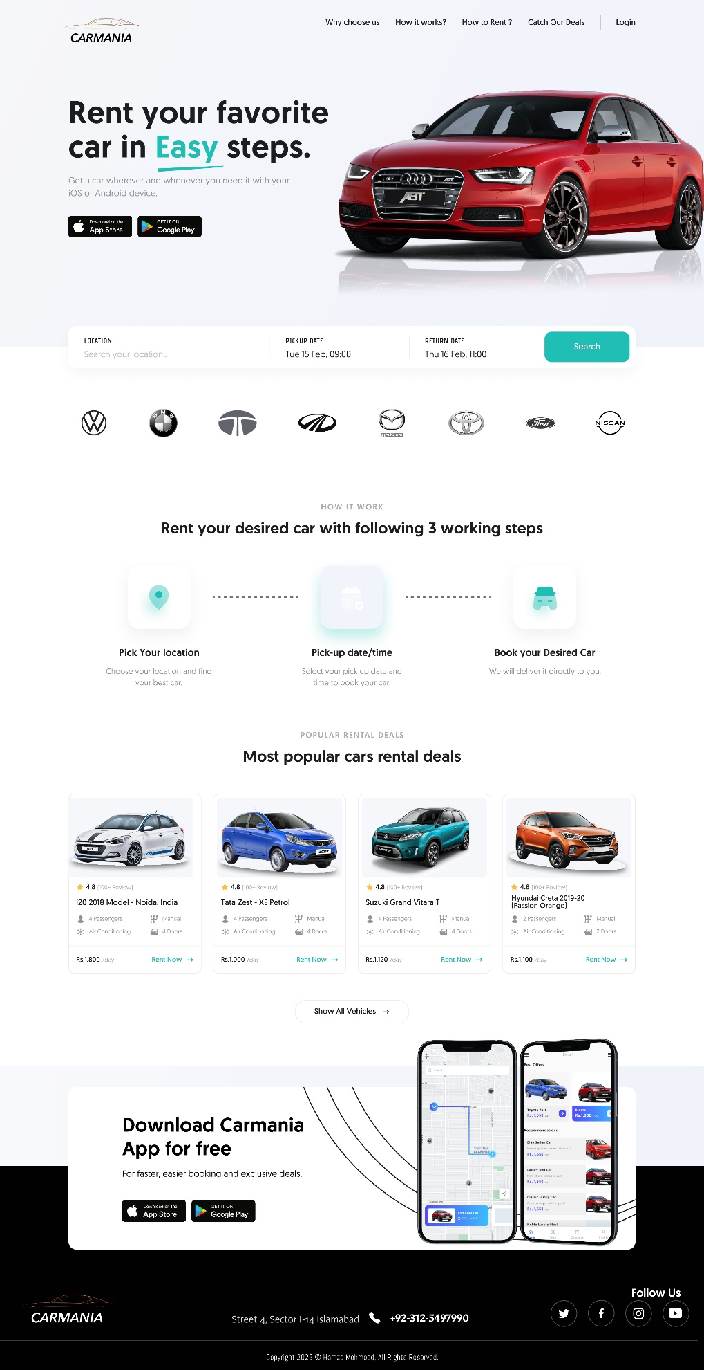

**Student’s Report:**

The visual hierarchy choices in the design is based on the **importance of the information**. The most important information, such as the **title and the steps to rent a car, are placed at the top of the design.** The less important information, such as the **app download and social media links,** are placed at the bottom of the image. This allows the viewer to quickly understand the main purpose of the design and how to use the service.

Visual hierarchy is achieved in this design through the **use of size, contrast, and positioning.** The most important information, such as the title **“Rent your favorite car in easy steps”** and the call to action **“Download Carmania App for free”** are larger and more prominent than other elements. The use of color also helps to draw the user’s attention to important information. The design also makes use of white space to create a clean and uncluttered look.

This is an advertisement for a car rental service called **Carmania.** The Design is divided into **three sections:** the top section, the middle section, and the bottom section. The top section has a red car on a white background with the title “Rent your favorite car in easy steps.” The middle section has three steps to rent a car: pick your location, pick-up date/time, and rent your desired car. The bottom section has a call to action to download the Carmania app and social media links.

The **reasoning** behind these visual hierarchy choices is to ensure that the most important information is easily accessible and visible to the user. By making the most important information larger and more prominent, users are more likely to notice it and take action. The use of color also helps to draw the user’s attention to important information. White space is used to create a clean and uncluttered look, which makes it easier for users to navigate the page.

|  |  |
| --- | --- |
| Is visual hierarchy achieved?   * size, contrast & positioning |  |
| Users' attention achieved? |  |
| Have explained the reasoning behind visual hierarchy choices? |  |
|  |  |

1. **Color Scheme Exploration**

Students will experiment with different color schemes (e.g., monochromatic, complementary, analogous) for a given design. They will evaluate the visual impact and emotional response evoked by each color scheme.

Report: Students will present their findings and discuss the effectiveness of different color schemes for specific design contexts.

**Student’s Report:**

Color schemes play a crucial role in the design of a website. They can evoke emotions, create visual interest, and help communicate information to the user. The effectiveness of a color scheme depends on the context in which it is used.

In the Carmania website design, the chosen color scheme is **monochromatic** with black, white, and cyan colors. This color scheme is effective in creating a cohesive and harmonious look. The use of red car adds a sense of excitement and energy to the design. The use of black and white with a pop of red creates a bold and striking contrast, while the use of cyan adds a touch of freshness and vibrancy. This color scheme is effective in **conveying a modern and sleek look.**

The **effectiveness of different color** schemes for specific design contexts can be explained by the emotional response evoked by each color scheme. For example, a complementary color scheme, which is two colors that are opposite each other on the color wheel, is effective in creating a **sense of balance and contrast.** An analogous color scheme, which is three colors that are next to each other on the color wheel, is effective in creating a **sense of harmony and unity.** Therefore, when designing a website, it’s important to **consider the context** in which it will be used and choose an appropriate color scheme that will evoke the desired emotional response from users.

|  |  |
| --- | --- |
| Chosen color schemes (monochromatic, complementary, analogous) |  |
| Have explained the emotional response evoked by each color scheme? |  |
| Explain the findings (in given design)? |  |
| Have discuss the effectiveness of different color schemes for specific design contexts? |  |
|  |  |

1. **Typography and Readability Analysis**

Students will analyze the readability and legibility (clear and understandable) of different typography choices in a provided design. They will assess the effectiveness of font selection, font pairing, hierarchy, and other typography elements.

Report: Students will present their analysis and provide recommendations for improving the typography in the design.

**Student’s Report:**

Typography is one of the most important element in web design. As for the Design’s typography, it is **clean and modern**. However, there are a few areas that could be improved:

- The font size for the body text is too small and could be increased for better readability.

- The text **"Rent your desired car with following 3 working steps"** is not aligned with the rest of the content and could be adjusted for better visual balance.

- The text **"Most popular cars rental deals"** is not aligned with the rest of the content and could be adjusted for better visual balance.

- The text **"Download Carmania App for free"** is not aligned with the rest of the content and could be adjusted for better visual balance.

**To improve the typography**, these following recommendations may be consider:

- Increase the font size of the body text to improve readability.

- Adjust the alignment of the text "Rent your desired car with following 3 working steps", "Most popular cars rental deals", and "Download Carmania App for free" to improve visual balance.

- Use a sans-serif font for headings to create contrast with the body text.

- Use a serif font for body text to improve readability.

- Use font weights to create hierarchy between headings and body text.

|  |  |
| --- | --- |
| Is design readable? |  |
| Is design legible? |  |
| Explain the findings (in given design)? |  |
| Selected font |  |
| Font pairing |  |
| Typography elements   * Font size’ * X-height * Gaps * White spaces |  |
|  |  |

1. **Layout Design Critique**

Students will review and critique a provided design layout in terms of grid usage, alignment, visual flow, and overall composition. They will identify strengths and areas for improvement in the layout.

Report: Students will provide constructive feedback and suggest modifications to enhance the visual appeal and user experience of the design.

**Student’s Report:**

**Here is some of the constructive feedback to enhance the visual appeal and user experience of the design:**

The design is organized **grid wise and aligned**. However, the **visual flow** could be improved by making the **text more readable** and the images more prominent. The **overall composition** is good, but the design could benefit from some modifications to enhance the visual appeal and user experience. Some **Modifications** include:

* Making the text more readable by increasing the font size or using a different font.
* Making the images more prominent by increasing their size or using a different layout.
* Adding more color to the design to make it more visually appealing.
* Improving the user experience by making the navigation more intuitive and user-friendly.
* The “Most popular cars rental deals” section could use more visual hierarchy. I would suggest using a different background color or adding a border to make it stand out.
* The “Download Carmania App for free” section could use more visual hierarchy. I would suggest using a different background color or adding a border to make it stand out.
* The text “Rent your favorite car in Easy steps” could be made more prominent by using a larger font size or a different font weight.
* The text “Most popular cars rental deals” could be made more prominent by using a larger font size or a different font weight.
* The text “Download Carmania App for free” could be made more prominent by using a larger font size or a different font weight.

**In terms of design modifications, I would suggest the following:**

* The red car at the top of the page is a bit too large and takes up too much space. I would suggest making it smaller and moving it to the right side of the page.
* The text “Rent your favorite car in Easy steps” is a bit too small and hard to read. I would suggest making it larger and more prominent.
* The “Most popular cars rental deals” section could use some more visual appeal. I would suggest adding more images of cars and making them larger.
* The “Download Carmania App for free” section could use some more visual appeal. I would suggest adding more images of the app and making them larger

|  |  |
| --- | --- |
| Is design organized (grid wise)? |  |
| Is design aligned? |  |
| Have achieved visual flow? |  |
| Achieved overall composition? |  |
| Have suggested modifications to:   * enhance the visual appeal * UX of the design |  |
|  |  |

1. **Accessibility Evaluation**

Students will assess a design for its accessibility considerations, such as color contrast, font size, and readability. They will identify any potential accessibility barriers and propose solutions to improve accessibility.

Report: Students will present their evaluation findings and discuss the importance of designing for inclusivity. Inclusive

**Student’s Report:**

The **design evaluation** findings for this design are that it is a well-designed website with **little shortcomings in visuals appealing** for a car rental service. The design is **clean and modern**, with a clear call to action and **easy to follow** steps. The **importance** of designing for inclusivity is that it ensures that all users, regardless of their abilities or background, can access and use the website. This is important for **businesses** to reach a wider audience and for **users** to have equal access to services.Inclusive design is about making design work accessible for as many people as possible. It benefits everyone by making places usable by everyone, regardless of age, ability, or circumstance. Inclusive design also expands product reach, builds empathy, sparks innovation, enhances user experience, improves search performance, creates a wider audience, and reduces absenteeism Therefore, inclusive design should be an integral part of any quality product or service.

|  |  |
| --- | --- |
| color contrast |  |
| font size |  |
| readability |  |
| Have discussed barriers? |  |
| Have proposed solution? |  |
| Have presented their evaluation findings? |  |
| Have discussed the importance of designing for inclusivity (comprehensive, complete, broad, general) |  |
|  |  |

**Lab 6 Report**

**Assigned Design:**

**San Diego Coupons: https://couponssandiego.com/**

**University of advancing technology: https://www.uat.edu/**

**Name: Hamza Mehmood**

**Class & Section: BS-SE 6TH (Evening)**

**Roll number: SP-21-110**

**Assigned Design: https://www.uat.edu/**

**Assessment:** Use/apply think aloud protocol, observational study, task analysis.Visual Design Elements, Color, Typography, Layout, Visual Hierarchy, Contrast and Visual Balance, Designing for Accessibility, Navigation, Readability.

Do attach screenshots with respective analysis

**Task and report with screenshots:**

1. **Planning and conducting a usability test:** Students will plan and design a usability test for a selected website or app. They will define the research objectives, develop test scenarios or tasks, and recruit participants. Students will conduct the usability test, ensuring that participants' interactions and feedback are observed and recorded.
2. **Collecting and analyzing usability data:** Students will collect data during the usability test, which may include video recordings, observation notes, questionnaires, or task completion rates. They will learn how to analyze the collected data to identify patterns, trends, and usability issues. Students will interpret the data to gain insights into the strengths and weaknesses of the design.
3. **Identifying usability issues and providing recommendations:** Based on the analysis of usability data, students will identify specific usability issues and prioritize them based on their impact on user experience. They will generate recommendations for design improvements, considering usability principles and best practices. Students will provide actionable suggestions to address the identified usability issues and enhance the overall user experience
4. **Presenting findings and recommendations:** Students will prepare a usability test report to present their findings and recommendations. The report will include a summary of usability test objectives, methods used, key findings, prioritized usability issues and recommended design changes. Students will effectively communicate their insights and recommendations in a clear & concise manner, targeting different stakeholders such as designers, developers and project managers.
5. **Visual Design**:

* **Analysis**: The website’s visual design is outdated and does not follow current design trends. The website’s color scheme is dull and unappealing, which makes it difficult to engage with the content. The typography is inconsistent, making it hard to read and understand the content.
* **Recommendation**: The header should be on the horizontal Side with clear instruction. Also Use a modern color scheme that follows current design trends.
* **Screenshot:** 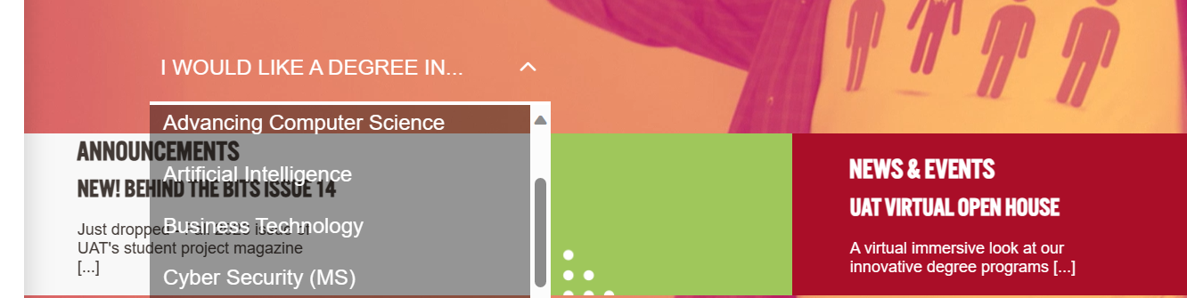

1. **Clarity & Conciseness**:

* **Analysis**: The website’s content is not concise and lacks clarity. The text is too long, making it difficult to read and understand. The website should use shorter sentences and paragraphs to make the content more readable.
* **Recommendation:** Use clear words as well as search need not to be hidden in menu it should be on left on the screen for user usability.
* **Screenshot:**

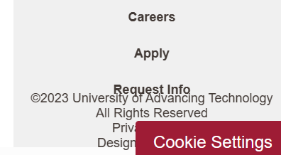

1. **Learnability**:

* **Analysis**: The website’s navigation is not intuitive, making it difficult for users to find what they are looking for. The website should use clear and concise labels for navigation links, and provide a search bar to help users find information quickly.
* **Recommendation:** Place the icons and content at their right place with proper Name and Relativity.
* **Screenshot:**



1. **Grids & Alignments**:

* **Analysis**: The website’s layout is not consistent, making it difficult to navigate. The website should use a grid system to ensure that all elements are aligned properly, which will make it easier for users to scan the content.
* **Recommendation:** The major Flaw is the usage of Horizontal Scrolling causing it difficult to be in align and thus it which should be changed.
* **Screenshot:**



1. **Color Scheme**:

* **Analysis**: The website’s color scheme is not consistent, which makes it difficult to read and understand the content. The website should use a consistent color scheme throughout the site to make it more visually appealing.
* **Recommendation:** Usage of Good Pastel Color Combinations
* **Screenshot:**

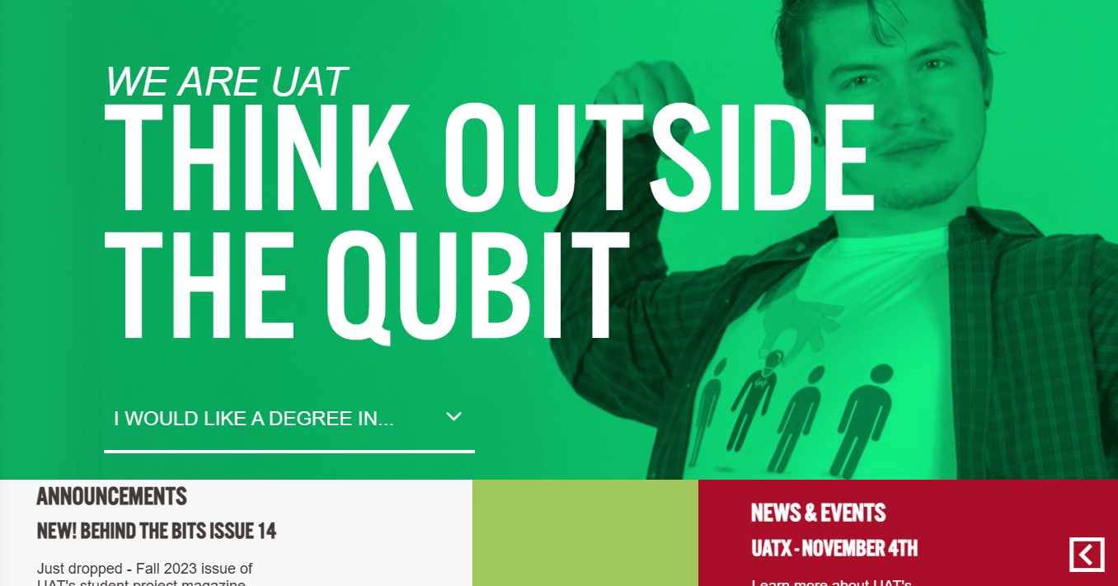

1. **Typography Analysis**:

* **Analysis**: The typography on the website is inconsistent, which makes it difficult to read and understand the content. The website should use a consistent font size and style throughout the site.
* **Recommendation:** The Typo nature should be changed to give a better look.
* **Screenshot:**

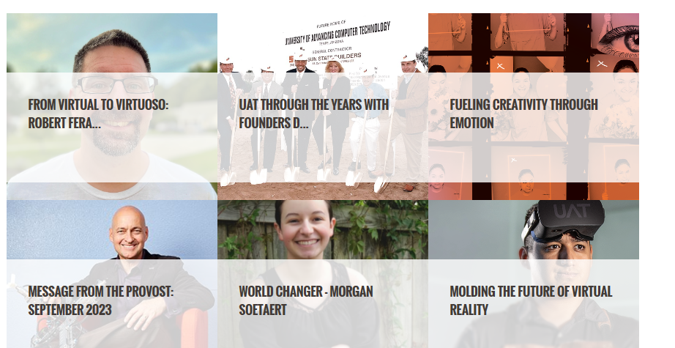

1. **Readability Analysis**:

* **Analysis**: The website’s content is not easy to read, which makes it difficult for users to engage with the content. The website should use shorter sentences and paragraphs, and break up long blocks of text with headings and subheadings.
* **Recommendation:** Place thing at their respective place.
* **Screenshot:**

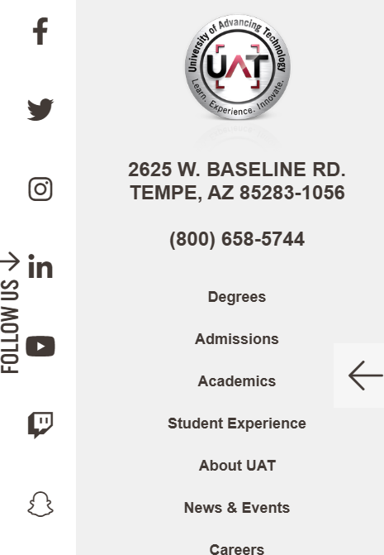

**Major Issues:**

* Outdated visual design
* Inconsistent typography
* Lack of clarity & conciseness
* Poor learnability

**Some Major Recommendations:**

* Use a consistent typography throughout the site.
* Use shorter sentences and paragraphs to improve clarity & conciseness.
* Improve navigation by using clear labels for navigation links.
* Use a grid system to ensure that all elements are aligned properly.
* Break up long blocks of text with headings and subheadings.
* Provide a search bar to help users find information quickly.

**Conclusion:**

In conclusion, the University of Advancing Technology’s website has **several** usability issues that need to be addressed in order to improve user experience. By implementing my recommendations, UAT can create a more engaging and user-friendly website that will help attract more visitors.

**Lab 7 Report**

**LAB 7: Mobile UX Design**

**Name: Hamza Mehmood**

**Class & Section: BS-SE 6TH (Evening)**

**Roll number: SP-21-110**

**Assigned Design: E-Commerce Design**

**Task 3 Assessment:** Students will create an interactive prototype of the mobile interface using prototyping tools or techniques. They will then conduct usability testing by inviting participants to interact with the prototype on actual mobile devices. Students will observe and gather feedback on the usability, efficiency, and overall user experience of the mobile interface.

Do attach screenshots with respective Link

**Version 1:** <https://www.figma.com/file/oLlFLGaObcpWjz8cZOSavC/Ecommerce-store-app-(Community)?type=design&node-d=1%3A3&mode=design&t=Cp84jwZBocx6fYMv-1>

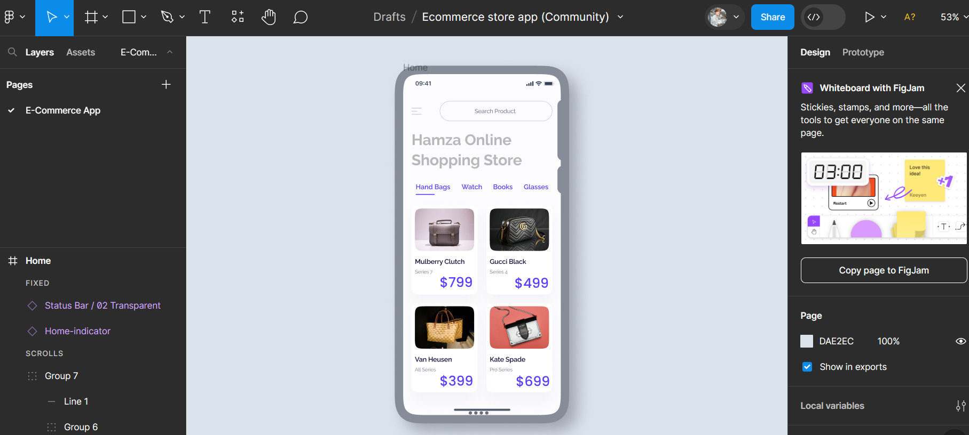

**Evaluating Recommendations:**

* The menu breadcrumb is too light to be visible.
* No Search Icon in search bar.
* Main Heading is too light to Visible.
* Sub Menus are of same color.
* Price font is too big.

**Task 4 Assessment:** Based on The feedback and insights gained from usability testing, students will iterate and refine the mobile interface. They will prioritize usability issues and design improvements identified during the testing phase. Students will make necessary revisions to the interface design, considering user feedback, and incorporating best practices for mobile UX design.

Do attach screenshots with respective Link

**Version 2:** <https://www.figma.com/file/oLlFLGaObcpWjz8cZOSavC/Ecommerce-store-app-(Community)?type=design&node-d=1%3A3&mode=design&t=Cp84jwZBocx6fYMv-1>

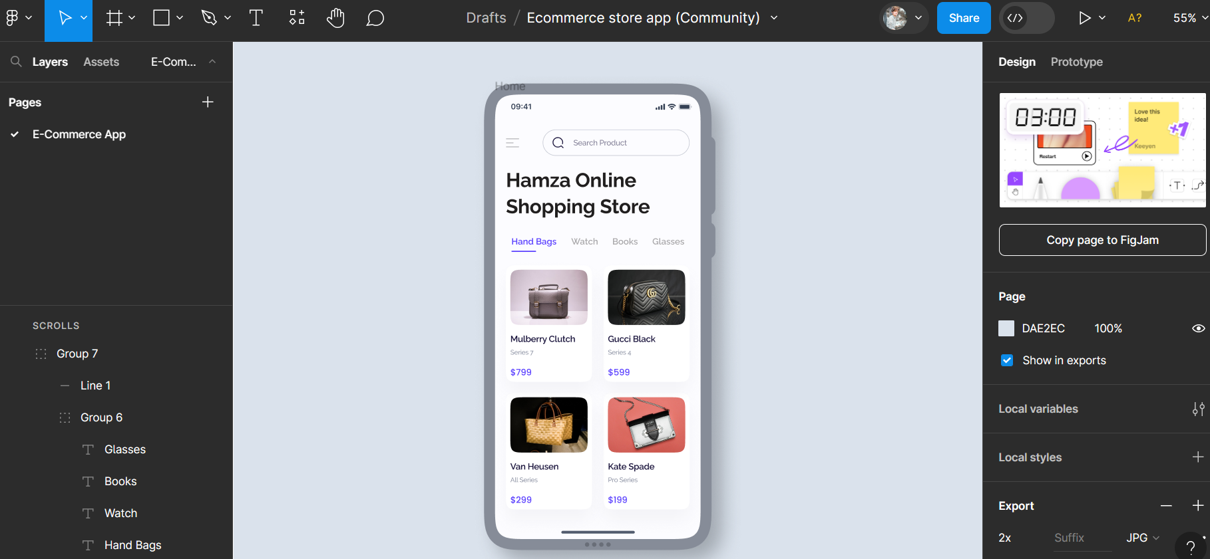

**Lab 8 Report**

**LAB 8: Accessibility in UX Design**

**Name: Hamza Mehmood**

**Class & Section: BS-SE 6TH (Evening)**

**Roll number: SP-21-110**

**Assigned Design: E-Commerce Design**

**Task Assessment:** Review and analyze accessibility guidelines and standards relevant to their target platform or context. They will then design and implement accessibility features in a website or app, incorporating the recommended accessibility techniques.

Do attach screenshots with respective Link

**Version 1:** [Hamza_Mehmood-CarMania – Figma](https://www.figma.com/file/4K2Z8IyRLtXlC1Gf47wm6C/Hamza_Mehmood-CarMania?type=design&node-id=1-32&mode=design&t=RZY5vd1j2uCAF9Jf-0)

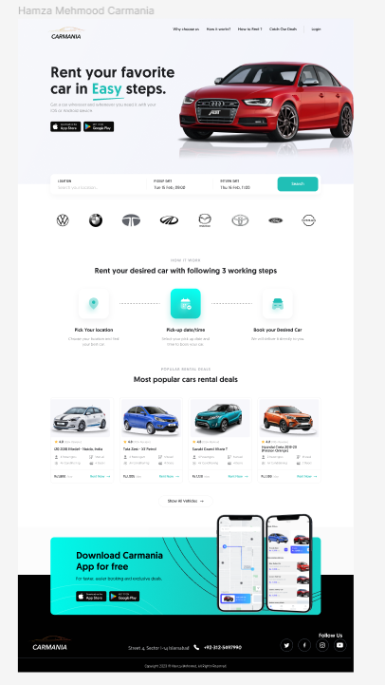

Page **1** of **2**

**Evaluating Recommendations:**

* The cyan color is difficult for color blindness people so replacing it.
* The car description font is too small.
* Changing color of Main Headline.
* Making Footer easily readable for colorblind people.

Do attach screenshots.

**Version 2:**

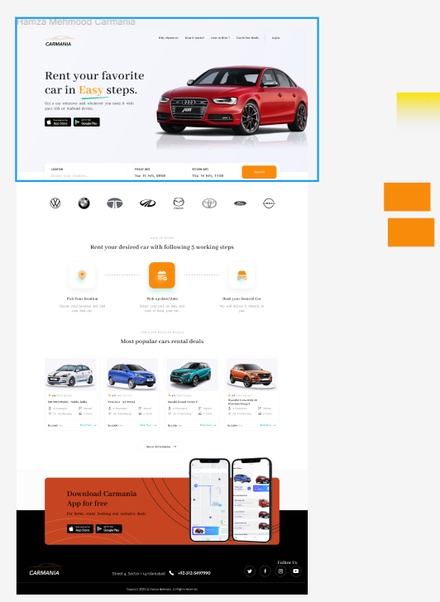

**Lab 9 Report**

**LAB 9: User-Centered Design**

**Name: Hamza Mehmood**

**Class & Section: BS-SE 6TH (Evening)**

**Roll number: SP-21-110**

**Assigned Design: Utility Store App Design**

**Tasks (with report):** **Report must include screenshots and figma design link.**

In this lab, students will have the opportunity to apply their knowledge of design in a practical setting. The lab tasks include:

1. **Conduct user research to gather insights into user needs and preferences**: In this task, students will plan and conduct user research to gain a deep understanding of the target users' needs, preferences, and behaviors. They will choose appropriate research methods such as **interviews,** surveys, or **observations** to collect data from users. Students will create research protocols, recruit participants, and conduct the research sessions. They will carefully analyze and synthesize the data collected to identify patterns, trends, and user insights.

**User Research (Interviews):**

**Objective:** To explore the shopping preferences of young professionals using the utility store mobile app.

**Method:**

**Participant Recruitment:**

Recruited 10 young professionals aged between 18-25 who use mobile apps for grocery shopping.

Ensure a balance of gender, occupation, and shopping frequency.

**Interview Guide:**

Questions include:

“How often do you use our utility store app for shopping?”

“What features do you frequently use, and why?”

“Can you describe a time when the app made your shopping easier or harder?”

“What improvements would you like to see in the app?”

**Data Analysis:**

Identify that most participants appreciate the app’s **quick checkout** feature but struggle with the **search functionality**.

**User Research (Observations):**

**Objective:** To observe the app’s usability when users are multitasking.

**Method:**

**Contextual Inquiry:**

Observe users at a cafe during lunch hours as they order groceries for the week.

Note their interactions with the app amidst distractions.

**Usability Testing:**

Users are asked to find and apply a coupon for their purchase.

Observers note that several users fail to locate the coupon section.

**Shadowing:**

Follow a user named Hamza as he uses the app while commuting on the train.

Notice that she uses the **favorites** feature to quickly add items to her cart but gets frustrated with occasional app crashes.

**Data Synthesis:**

Compile observations and find that users needs a **stable app experience** during commutes.

**2)** **Generate design ideas and create prototypes based on user research findings:**

Based on the insights gathered from user research, students will generate design

ideas and concepts. They will brainstorm potential solutions and explore different

approaches to address user needs and preferences. Students will then create

prototypes to visualize and communicate their design ideas.Do attach screenshots with respective Link

**Version 1:**

[**https://www.figma.com/file/jdeaC37OXoUNIxgOYe48SP/Hamza-grocery-store?type=design&node-id=0%3A1&mode=design&t=E9s96HStUEXC8t9d-1**](https://www.figma.com/file/jdeaC37OXoUNIxgOYe48SP/Hamza-grocery-store?type=design&node-id=0%3A1&mode=design&t=E9s96HStUEXC8t9d-1)

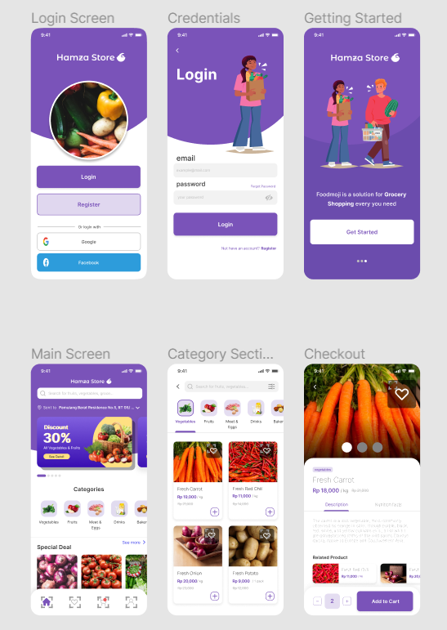

Page **1** of **2**

**Evaluating Recommendations:**

* The Buttons are too big.
* Important Icons should be there.
* Login Text and Forgot Password is not in Position.
* Slide Button should be in Center.
* Item text is too thin.
* Heart icon is too big.

**4) Iterate and refine the design based on user feedback:** Based on the feedback received from users during the testing phase, students will analyze the data and identify areas for improvement. They will iteratively refine their design by making necessary adjustments, addressing usability issues, and incorporating user suggestions. Students will consider the feedback received and prioritize design changes that align with user needs and preferences. They will update their prototypes accordingly and prepare for subsequent testing cycles.

Do attach screenshots with respective Link

**Version 2:** [**https://www.figma.com/file/jdeaC37OXoUNIxgOYe48SP/Hamza-grocery-store?type=design&node-id=0%3A1&mode=design&t=E9s96HStUEXC8t9d-1**](https://www.figma.com/file/jdeaC37OXoUNIxgOYe48SP/Hamza-grocery-store?type=design&node-id=0%3A1&mode=design&t=E9s96HStUEXC8t9d-1)

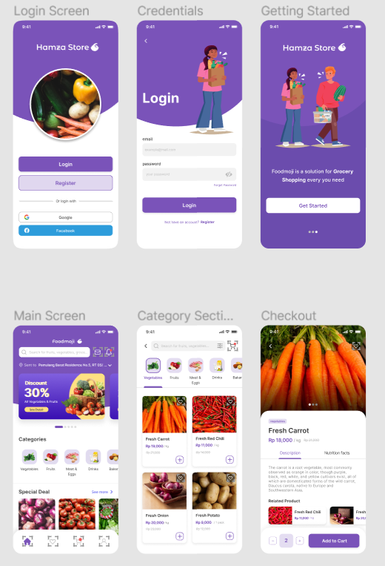

**Question 1:** How often do you **visit** NUML's website?

|  |  |  |
| --- | --- | --- |
|  | Daily | 12 |
|  | Weekly | 45 |
|  | Monthly | 17 |
|  | Yearly | 3 |

**Question 2:** How would you **rate the overall design** of NUML's website?

|  |  |  |
| --- | --- | --- |
|  | Excellent | 5 |
|  | Good | 31 |
|  | Fair | 29 |
|  | Poor | 8 |
|  | Very Poor | 4 |

**Question 3:** Is the **navigation menu** on NUML's website intuitive and easy to use?

|  |  |  |
| --- | --- | --- |
|  | Yes | 33 |
|  | Neutral | 35 |
|  | No | 9 |
|  |  |  |

**Question 4:** How satisfied are you with the **load time** of NUML's website pages?

|  |  |  |
| --- | --- | --- |
|  | Very satisfied | 23 |
|  | Neither satisfied nor dissatisfied | 35 |
|  | Very dissatisfied | 19 |

**Question 5:** Do you find it **easy to locate** information such as course details, faculty information, and contact information on NUML's website?

|  |  |  |
| --- | --- | --- |
|  | No | 24 |
|  | Neutral | 28 |
|  | Yes | 25 |

**Question 6:** Have you encountered any issues with **broken links** or **missing content** on NUML's website?

|  |  |  |
| --- | --- | --- |
|  | Yes, frequently | 11 |
|  | No, never | 37 |
|  | Yes, occasionally | 29 |

**Question 7:** How would you rate the **responsiveness** of NUML's website on different devices (e.g., desktop, tablet, smartphone)?

|  |  |  |
| --- | --- | --- |
|  | Excellent | 7 |
|  | Good | 34 |
|  | Fair | 28 |
|  | Poor | 3 |
|  | Very Poor | 5 |

**Question 8:** Are you aware of any **accessibility features** on our website for individuals with disabilities? (e.g., screen reader support, text-to-speech, alt text)

|  |  |  |
| --- | --- | --- |
|  | No, I was not aware | 59 |
|  | Yes, and they are helpful | 11 |
|  | Yes, but they need improvement | 7 |

**Question 9:** Do you find the **search functionality** on our website effective in helping you find information?

|  |  |  |
| --- | --- | --- |
|  | Not at all effective | 16 |
|  | Neutral | 52 |
|  | Very effective | 9 |

**Question 10:** Would you **recommend**NUML's website to others based on your current experience?

|  |  |  |
| --- | --- | --- |
|  | Not at All | 19 |
|  | Neutral | 35 |
|  | Definitely Yes | 23 |

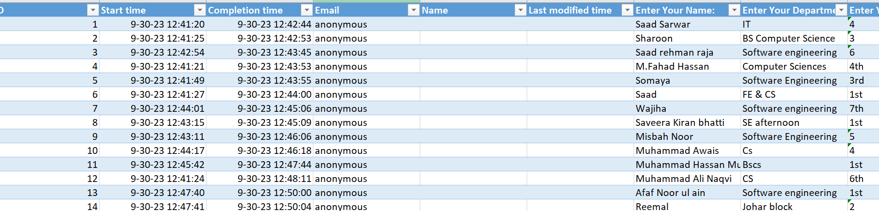

**Final Lab Exam**

Design Link: <https://www.figma.com/file/UiooZv3NSAIi4Z7BZTT97E/Lab-Exam?type=design&node-id=0-1&mode=design&t=fXWn7QcL2ODYyX98-0>